Email Encryption Instructions

Go to https://www.medteleco.com/
Click on three red lines and choose Clients
Click on the E-mail Decryption Program link and open
A box will open, click on EmailDecryptSetup

Another box will open, choose extract all
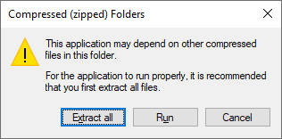
Select a Destination and Extract Files will open, click Extract
Once you do that another box will open

Double Click EmailDecryptSetup
If Windows blocks the program click more info and then run anyway
Another box will open choose yes to allow changes
Then follow the setup wizard
Make sure that you leave create a desktop icon checked
Once install is complete close all the open boxes
Right click on the desktop icon and choose run as administrator
Click yes to allow changes and/ or put in admin username and password
Once that is complete a box will open

Click on the Options tab
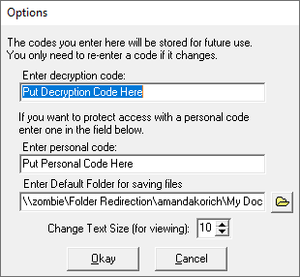

Enter code (Your MTC account number)
Leave personal code blank then choose okay
Close window.

